

**A**

**REPORT**

**On**

**An Exploratory Study of Parental Attachment Styles and Their Influence on Child Development and Behavioural Outcomes**

Submitted to

**MIT ADT UNIVERSITY**

**SCHOOL OF ENGINEERING & SCIENCE**

**DEPARTMENT OF APPLIED SCIENCE & HUMANITIES**

In partial fulfilment of the requirements for the award of the degree of

**MASTER OF SCIENCE**

**IN**

**APPLIED STATISTICS (DATA SCIENCE)**

Submitted by

**Saurabh V. Bhosale MITU22MSDS0032**

**Gaurav B. Bhoite MITU22MSDS0008**

Under the Guidance of

Guided by Co-guided by

Dr. Pratibha Jadhav Prof. Sunil Thakre

June, 2024

**Chapter-I**

**INTRODUCTION**

The parent-child relationship is one of the most essential relationships in a person's life. The three pillars of this parent-child relationship are respect, trust, and love. Parents have a responsibility to give their children clothing, food, and shelter. They also give their kids love, support, and direction. For children to grow up to be healthy, happy individuals, their parents are essential. The bond between a parent and kid is intricate. The nature of the relationship varies with time. Children's needs alter as they mature and develop. The ability to adjust to their children's evolving demands is a must for parents. At every step of their development, they must be able to give their kids the love, support, and direction they require. The bond between a parent and child persists for a lifetime. This is a relationship that has to be cherished. The goal of a secure, loving relationship between parents and children should never waver. The child's behaviors, attitudes, and general well-being are shaped by it, and it forms the basis for their emotional and social development. Parenting techniques and attachment styles are essential to the quality of this relationship since they are critical in providing a safe and caring environment for the child.

We are motivated to learn more about how parental attachment types affect children's behavior in order to improve our understanding of parent-child relationships and foster developmentally healthy results for children. The initial years of life are crucial for a kid’s emotional, social and behavioral progress. with attachment styles playing a significant role. Understanding how these styles impact child behavior is essential for promoting positive development and well-being. Behavioral issues, such as aggression, anxiety, hyperactivity, and social difficulties, are growing concerns in children. Secure attachment fosters a sense of safety, security, and self-worth, while insecure attachment styles can lead to emotional dysregulation, difficulty forming healthy relationships, and increased vulnerability to behavioral problems. Modern parenting landscapes, including social media, changing family structures, and dual-income households, can influence attachment bonds.

Therefore, our goal is to acquire useful information through thorough research and analysis that can guide interventions, plans of action, and regulations designed to promote positive parent-child relationships and improve the overall well-being of children.

The purpose of this study, "A Comprehensive Analysis on Exploring the Impact of Parental Attachment Styles on Child Behavior," is to study the complex dynamics of parent-child relationships to identify the ways in which various factors affect the results of child behavior. This study focuses at the relationships between parenting styles, child behavior, and parental attachment patterns in an effort to identify the underlying mechanisms which contribute to the development of behavioral problems in kids. Parental behaviors and attitudes toward concern are known to be influenced by their attachment styles, which are derived from their early childhood experiences. There are variations in parental responsiveness, emotional expression, and relationship quality overall that have been connected to these attachment types, which include secure, avoidant, ambivalent, and disordered. It is essential for understanding how these attachment patterns affect children's behavior in order to identify potential risk factors and carry out focused interventions. Moreover, parenting styles that are warm, attentive, in charge, and consistent are also very important in molding a child's behavior.

Through conducting a comprehensive investigation that includes questionnaire-based surveys, statistical analyses, and predictive modeling, this study effort aims to clarify the complex relationship between parenting styles, parental attachment types, and the behavioral outcomes of children. This study aims to provide useful insights for child development and family psychology academics, practitioners, and policymakers by identifying important elements and underlying mechanisms. Different attachment styles may have various impacts on kids emotional, public, and interactive growth, according to an increasing amount of study. Parents that are securely bonded are typically receptive, positive, and give their kids a secure and caring atmosphere. This helps kids feel secure emotionally and have a higher sense of self, which improves their social skills and decreases behavioral issues On the other hand, emotional distance, inconsistent behavior, or even neglect are characteristics of insecure attachment styles, such as avoidant, ambivalent, or disorganized.

These approaches may exacerbate behavioral issues in kids by having an adverse impact on their ability to control their emotions and social skills.

This study aims to provide a more comprehensive understanding of the ways in which parental attachment types impact child behavior. We want to add important new information to the study of child development by identifying these relationships. Finally, by using this knowledge to guide interventions and techniques, parents and children can build stable attachment relationships that support the best development for kids and wellbeing. In conclusion, the goal of this research project is to inform methods aimed at building positive parent-child interactions and resolving behavioral difficulties in children, as well as to further our understanding of how parental attachment types affect child behavior.

**Chapter-II**

**LITERATURE REVIEWS**

Number of studies has been done based on the Parent child relationship has been used in a change of study. Some of the related work contains:

1. Ainsworth et.al (2015) [1], Ethological attachment theory, a 20th-century approach to understanding primary relationships, Mary D. Salter Ainsworth's Baltimore Longitudinal Study emerged after John Bowlby critiqued psychoanalytic drive theory and shared his clinical observations, which yielded enduring results on a child's tie to their primary caregiver, addressed common developmental and longitudinal issues. The study also introduced new concepts and clarified existing ones. As we arrive the fourth generation of attachment learning, a rising list of behavior and description approaches to measurement attachment from beginning to maturity is rooted in Patterns of Attachment.
2. Cox et.al (2003) [3], Research on parenting is crucial in understanding how children become adults and functioning well in society. Childhood socialization occurs in families, daycare centers, schools, and peer groups. The quality of parent-child relationships is particularly important for emotional and social development. This chapter reviews major work on the links between parent-child relationships and child well-being, addressing definition, measurement, characteristics of positive relationships, and factors affecting their development.
3. Stephens et.al (2009) [10], have determined gender alterations in child-care graces and their impact on parent-child relationships. Participants were given demographic questions and the Parent Attachment Inventory to measure maternal repair and protective. Results showed significant gender differences in parenting styles, with mothers’ expenditure more period with their children and children sensitivity faster to their moms. Fathers were extra likely to be domineering of their sons.
4. Novaković et.al (2017) [8], this paper explores the evaluation of machine learning classification models, focusing on finding optimal solutions. The main criterion is classification accuracy, but it neglects error types and class distribution. The paper discusses the selection of appropriate measures based on problem characteristics and implementation methods.
5. Sarker et.al (2019) [9], this study analyzes the efficiency of ML classifiers for forecasting personalized smartphone usage using device log data. Ten classic machine learning techniques are employed, along with the Artificial Neural Network-based organization classical. The study also compares the effectiveness of these models on real mobile datasets. The results can help researchers and developers design bright context-aware organizations for mobile phone handler, enhancing their experience with progressive landscapes and context-awareness in smart mobile phones.
6. Chambers et.al (2017) [4], this chapter discusses statistical models, which are simplified descriptions of data derived from mathematical or numerical relationships. It consists of three parts: a formula defining the structural form of the model, data to be applied to the model, and a stochastic part addressing discrepancies between data and fit. Models imitate real objects, making inferences and applying them to real objects.
7. Ali et.al (2016) [2], contribute significantly to the field of research methodology by offering a detailed guide on statistical methods. Their work supports researchers in planning, designing, collecting, analyzing, and reporting data, and ensuring robust and reliable research outcomes. It covers variables, measurable and qualitative measures, central tendency measures, sample size estimation, influence analysis, statistical errors, and parametric and nonparametric tests used for data study. The paper is a valuable reference for anyone involved in conducting research, providing essential tools and knowledge to enhance the quality and credibility of their studies
8. Dalati et.al (2018) [5], this chapter explores survey questionnaires as primary data collection tools in business research, focusing on data sources, authority, observation, and communication approaches. It examines self-administered questionnaires, their advantages and disadvantages, questionnaire design, structure, item content, wording, and response strategy. The chapter also discusses the impact of open-ended or closed-ended responses on research objectives.
9. Horváth et.al (2024) [6], Horváth and Trapani (2022) developed a family of CUSUM-based change point tests for a Random Coefficient Autoregressive model. This paper adds to their work by studying the Likelihood Ratio statistic, showing it has power versus breaks even near O (log log N) periods. Quasi Maximum Likelihood based estimates yield better power properties and are nuisance-free. The test statistic has the same distribution regardless of data stationarity, and simulations show good power and correct size. The approach is useful for economic and epidemiological time series.
10. Jayaprakash et.al (2024) [7], Autism spectrum syndrome is a heterogeneous condition characterized by diverse personality traits, cognitive abilities, and emotional types. The Baby Autism Rating Scale (CARS) means is used to clinically evaluate children aged 6 months to 5 years with developmental delays. Multinomial logistic regression is used to classify structures of develop delays, such as social relatives, communiqué, and unknown activities. The ML model exercise MLR-lbfgs products 89%, MLR-sag 80%, MLR-saga 80%, and MLR-newton-cg 97%. This tool supports clinicians in making accurate and immediate decisions when identifying unsown autistic topographies or unsure conditions.

**Chapter-III**

**AIM AND OBJECTIVE**

**Aim:**

This study explores parent-child relationships and child development, examining factors like attachment styles, parenting approaches, and demographics. It aims to identify factors and provide insights for improving parent-child relationships.

**Objectives:**

1. To determine whether there is a relationship among different age groups of parents to expressing emotions.
2. To determine the relationship between parenting attachment styles and child interaction as well as behavior quality.
3. To identify and analyze the different variables affecting children’s academic performance.
4. To Study the Effects of Parental Attachment and Parenting Style on the Quality of the Parent-Child Relationship.
5. To investigate the association between parenting approaches and parent’s interactions with children.
6. To build predictive models for child behavioral problems and identify the most influential Variables.

**Chapter-IV**

**METHODOLOGY**

The primary data for this study was meticulously collected using a Google Form that was circulated to parents. The purpose of the form was to collect category-based information about parent-child relationships. The Google form contained 19 multiple-choice questions. For the study, 390 responses all around were collected. Because the data was categorical in nature, the Likert scale was used to systematically encode it. This 3- or 4-point scale was a useful tool for assessing how different parental attachment styles influence the behavior of their children. The encoded data was subjected to an initial analysis. This was an important step that included figuring out the main features of the data, finding the underlying structure, extracting out important variables, looking for variations, and testing underlying assumptions. Understanding complex patterns was made easy by a visual summary given by a graphical representation of the data.

**Data Collection:** The study will develop a comprehensive questionnaire to explore parental attachment styles, parenting approaches, child behavior, and demographic information. Participants will be recruited through online platforms, social media, and community organizations, ensuring diversity in demographics. Data will be collected electronically or in person, with clear instructions for uniformity and participants' convenience in completing the surveys.

**Data Structure**: Our dataset contained 19 variables (columns) and 390 observations (rows). Each row represents an individual case or participant in the study, capturing detailed information about parental characteristics, parenting styles, child demographics, and child outcomes.

The dimension of the file is: 390 X 19

The data is Nominal, Ordinal, Discrete, Continuous type.

**4.1. Data Description**

The primary dataset appears to be designed for a study on parenting styles and their impact on child development. The data contains variables related to parent information, child information, parenting styles and behaviors, child development and outcomes, and potentially some socioeconomic factors and parent-child activities. Here's a breakdown of the variables and their potential characteristics:

|  |  |
| --- | --- |
| **Name of Variables** | **Description of Variables** |
| Parent_age | This variable likely represents the age (in years) of parents. |
| Parent_Gender | This variable indicates the gender (e.g., Male, Female). |
| Child_Age | This variable represents the age (in years) of the child. |
| Child_Gender | This variable indicates the gender (e.g., Male, Female). |
| Number_of_Children | This variable specifies the entire number of children in the family. |
| Family_members | This variable might capture details about the family information. |
| Parental_Attachment | This variable explores the parent's attachment style with their children. |
| Parenting_Approach | This variable refers to the overall parenting style. |
| Comfort_Expressing_Emotions | This variable indicates how comfortable parents and child feel expressing emotions. |
| Response_to_Needs | This variable explores how parents respond to their child's needs. |
| Relationship_with_child | This variable assesses the excellence of the parent-child association. |
| Behavioral_Problems | This variable might indicate the presence or absence of behavioral issues in the child. |
| Interaction_with_Others | This variable explores how the child interacts with others. |
| Academic_Performance | This variable refers to the child's performance in school. |
| Education_Level | This variable indicates the educational level of the parents. |
| Both_parents_working_full_time | This variable specifies if both parents work full-time or not. |
| Employment_Status | This variable provides details about the employment status of the parents. |
| Bonding_activities_with_child | This variable explores the types of activities parents engage in with their children’s. |
| Affected_Relationship_with_child | This variable might be related to how external factors (e.g., stress, work-life balance). |

Table 4.1: Discerption of Variables

**4.2. Computational Tools**

About the most common data science tools second-hand to perform Data Analysis:

* **Python**:

A dynamically semantic, object-oriented programming language interpreter. Its dynamic typing and dynamic binding, along with its high-level built-in data structures, make it an appealing language for quickly developing applications and for use as a scripting or glue language to join disparate components. It's crucial to determine how to handle missing values for machine learning by using Python and EDA together to find missing values in a data set.

* **R**-**Software:**

A free software environment and open-source programming language for statistical computing and graphics that are backed by the R foundation. When creating statistical observations and conducting data analysis, statisticians in the field of data science frequently utilize the R language

* **Tableau**:

Tableau is a data visualization tool that is mainly used for decision-making in the business intelligence domain. Tableau facilitates data analysis and dashboard creation for insights. Tableau is a data visualization tool that is mainly used for decision-making in the business intelligence domain. Tableau facilitates data analysis and dashboard creation for insights.

* **Power BI**:

Data analysts are the primary users of power bi, a self-service bi tool that makes data analytics accessible to staff members. Management and department representatives use Microsoft Power Bi to generate reports and forecasts that help sales and marketing representatives and give management information on how the department or specific employees are doing in terms of reaching their objectives.

* **SPSS(Statistical Package for Social Sciences):**

SPSS is a software program largely employed for statistical analysis in diverse fields such as social sciences, market research, healthcare, and more. Initially developed by SPSS Inc. in 1968, it was later acquired by IBM in 2009. SPSS is used on a large scale as it is easy to understand and use. SPSS provides a range of tools and functions to perform data manipulation, descriptive statistics, hypothesis testing. Regression analysis, and data visualization. SPSS offers a user-friendly interface that allows researchers and analysts to import data from different sources, clean and transform the data, and apply statistical techniques to gain insights and draw conclusions.

* **Exploratory data analysis (EDA):**

EDA is the process of examining and analysing a dataset to understand its characteristics, identify patterns, and discover relationships between variables. It is a process that involves collecting, cleaning, transforming, and visualizing data. EDA is a process used for visualisation and summarisation of data and finding meaningful insights from the data. Data scientists can make sure their findings are reliable and relevant to any intended business objectives by using exploratory analysis. By verifying that stakeholders are posing pertinent questions, eda further assists them. Questions concerning confidence intervals, categorical variables, and standard deviations can all be addressed by eda. After eda is finished and conclusions are made, its features can be applied to more complex data analysis or modelling, such as machine learning. EDA is an essential part of the data science process, and it can help us to get the most out of our data. By understanding the data, we can make better decisions and develop more accurate models.

**4.3. Data Preprocessing**

To clean and transform raw data for data mining, data pre-processing is a crucial step. It includes tasks like treatment missing values, removing outliers, growing structures, and coding unconditional variables. By pre-processing the data, we ensure that data is in right format and ready for training our models. Data pre-processing is a primary step in machine learning where we prepare our data before training our models. It involves various techniques to clean, transform, and enhance the quality of our data.

Typical data pre-processing steps include the following:

* One important task in data preprocessing is handling missing values. We need to decide how to handle missing data, such as replacing them with the mean or median of the feature, or using more advanced techniques like regression or imputation.
* Encoding categorical variables is another important preprocessing step. Machine learning models typically work with numerical data, so we need to change categorical variables into arithmetical representations. This cannister be done by using techniques like label encoding.
* Data preprocessing helps us in achieving better model performance and more accurate predictions. It ensures that our data is in the right format, free from inconsistencies, and ready to be fed into our machine learning models.

**4.4. Data Transformation**

Transforming categorical variables into numerical ones is a crucial step in preparing the dataset for analysis, especially for statistical modelling and machine learning algorithms. Here’s a thorough account of the data transformation process performed on the primary dataset:

1. **Identifying Categorical Variables**: First, identify the categorical variables present in the primary dataset, and then apply the transformation techniques to selected variables.
2. **Data Transformation Methods:** Various methods can be used to transform categorical variables into numerical representations. For this dataset, we use the following techniques:

* Label Encoding: This method changes unconditional values into numeric values, transfer a exclusive integer to each group. It is useful for ordinal variables, where here is a telling order among the classes.
* One-Hot Encrypting: This technique adapts definite values into a binary vector where each unique class is embodied by separate column. It is suitable for nominal variables, where there is no inherent order among the categories.

1. **Transformation Process**

* Label Encoding: For ordinal variables like Education_Level and Behavioral_Problems, label encoding is used to convert each category into a corresponding integer. This method preserves the ordinal relationship between the categories.
* One-Hot Encoding: For nominal variables like Parent_Gender, Child_Gender, Employment_Status, Parenting_Approach, and Bonding_activities_with_child, one-hot encoding is applied.

The final dataset, transformed into numerical form, is now ready for statistical analysis and modelling. This transformation ensures compatibility with various models and machine learning algorithms, allowing for more effective analysis of the association among paternal factors and child results. The dataset's structure changes after label encoding and one-hot encoding, resulting in more accurate and meaningful results in the research study.

**4.5. Data Visualization**

1. **Comfort of Expressing Emotions among Different Age Groups of Parents:**

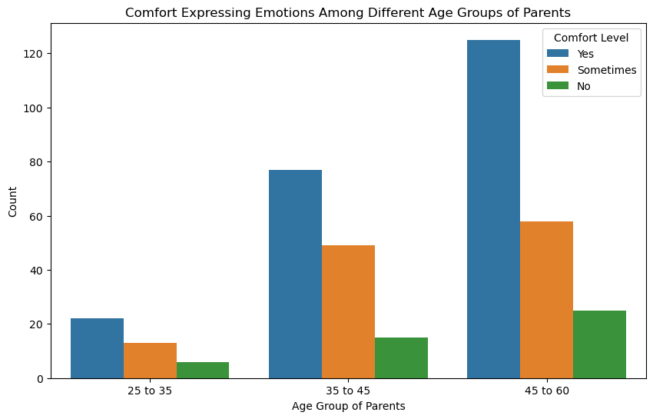

Fig: 4.1

**Interpretation**: - According to the graph, children between the ages of 45 and 60 are most comfortable expressing their emotions to their parents. This could be attributed to older parents' maturity and experience, as they may be more patient, understanding, and emotionally supportive. These characteristics are likely to foster a safe and open environment in which children can express their feelings, resulting in stronger emotional connections and trust.

1. **Parenting Approach Towards Child:**

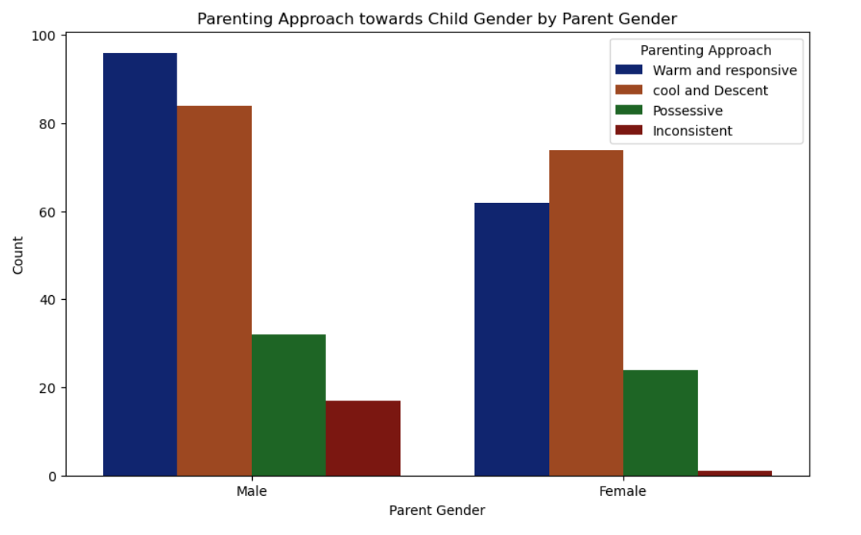  
Fig: 4.2

**Interpretation**: - The graph shows that there are noticeable differences in parenting approaches based on the parent's gender. The data suggests that male and female parents may use different strategies when interacting with children of different genders. For example, certain parenting approaches may be more common among fathers than mothers, and vice versa, implying that gender influences how parents raise their children. This difference could be attributed to a variety of social, cultural, and personal factors that influence parental behavior and expectations.

1. **Relation Between Parental Attachment Style & Child Behavior :**

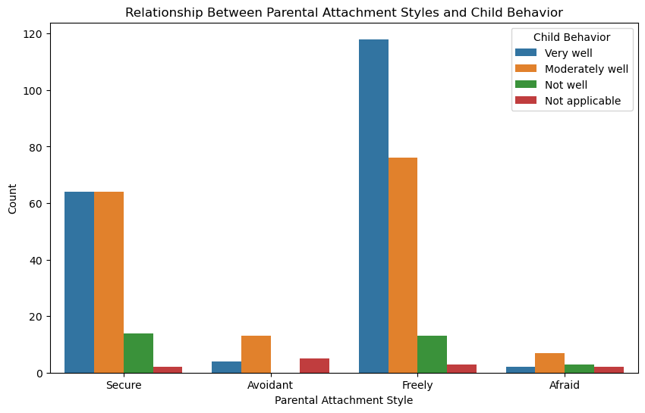

Fig: 4.3

**Interpretation**: - The graph shows that children with a freely parenting attachment style have a higher number of positive interactions with others. This suggests that such a parenting style is linked to improved social behaviors in children, allowing them to interact more effectively and confidently with their peers. The supportive and less restrictive nature of freely parenting may create an environment in which children feel safe and encouraged to explore social interactions, resulting in improved social skills and behavior.

**D. Correlation Heatmap:**

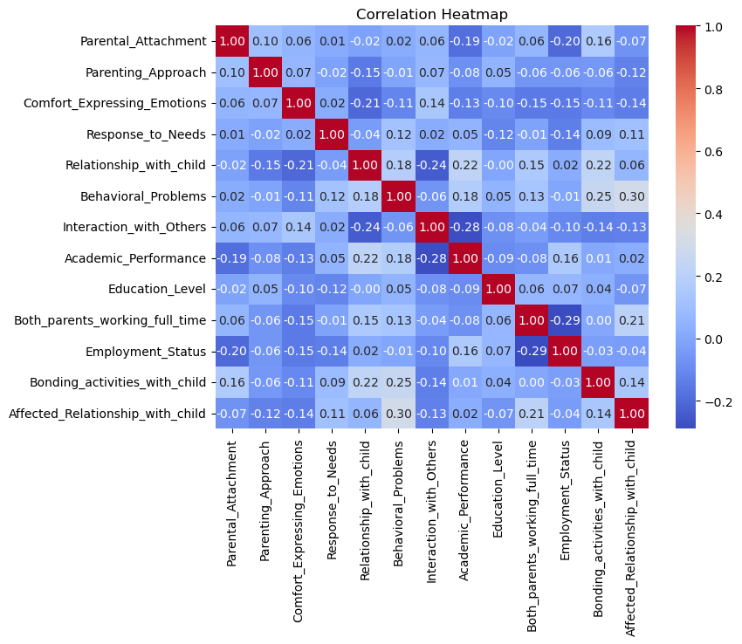

Fig: 4.4

**Interpretation**: - The heatmap is a tool for analyzing correlation between variables, with color intensity indicating the relationship. It shows a negative correlation between bonding activities and academic performance, but does not necessarily indicate causation. The heatmap also shows positive correlations between parental attachment and academic performance, negative correlations between behavioral problems and academic performance.

**Chapter-V**

**DATA ANALYSIS**

**5.1 Multinomial Logistics Regression**

Multinomial logistic regression is used when the dependent variable has further than 2 classes. It is generalization of logistic regression. In our research study, the dependent variable Academic performance has more than 2 categories such as above average, Average and below average, the equation of multinomial logistic regression is as follows:

$$P[Y = y] =\frac{exp (b0 + b₁X1+b2 X2+………+ bn Xn)}{1+exp⁡((b0 + b₁X1+b2 X2+………+ bn Xn)}$$

Where,

Y = Dependent variable

X1, X2, X3………….. Xn = Independent variables

b0 = Intercept

b1, b2, b3,………bn Coefficients w.r.t. X1, X2, X3………….. Xn

The assumptions of multinomial logistic regression are as follows:

1. Dependent variable must be also ordinal or nominal.

2. More than one independent variable can be continuous, ordinal, or nominal.

3. Dependent variable is mutually exclusive and exhaustive.

4. There should be no multicollinearity between independent variables.

Assumptions 1, 2, and 3 are satisfied by mere observations of data. To check assumption 4 multicollinearity, SPSS software is used. Multicollinearity is determined using VIF (Variance Inflation Factor). If VIF is greater than 10 then it indicates higher multicollinearity.

1. Multicollinearity of Variables

Table 5.1: Multicollinearity of Variables

|  |  |  |
| --- | --- | --- |
| Coefficients | | |
| Models | Collinearity Statistics | |
| Tolerance | VIF |
| Parental Attachment | .917 | 1.090 |
| Parenting Approach | .917 | 1.090 |
| Comfort Expressing emotion | .938 | 1.066 |
| Response to Needs | .917 | 1.091 |
| Relationship_with_child | .865 | 1.156 |
| Behavioral_Problems | .882 | 1.134 |
| Interaction_with_Others | .882 | 1.134 |
| Education_Level | .954 | 1.048 |
| Both_parents_working_full_time | .833 | 1.200 |
| Employment_Status | .840 | 1.190 |
| Bonding_activities_with_child | .864 | 1.158 |
| Affected_Relationship_with_child | .892 | 1.121 |
| Dependent Variable: Academic_Performence | | |

In table 5.1: All the Variables present in the data have VIF less than 10. Hence we are consider all variables for further data modelling.

* **To identify and analyze the different variables affecting children’s academic performance:**

Data modelling is performed using SPSS Software. The likelihood ratio test table is used to identify significant variables. The variables having significance greater than 0.05 are insignificant and do not contribute to the model, hence they are discarded. The variables having significance less than 0.05 are significant und are considered in the model. The parameter estimates table gives the intercept, coefficients with respect to independent variables and the odds ratio, the model of academic performance along their outputs are discussed below:

* **Likelihood Ratio Test Table**

Table5.2: Likelihood Ratio Test for Academic_Performence

|  |  |  |  |  |
| --- | --- | --- | --- | --- |
| Effect | Likelihood Ratio Tests | | | |
| -2Log Likelihood of Reduced Model | Chi-Square | df | Sig. |
| Intercept | 464.4923 | 0.000 | 0 |  |
| Bonding_activities_with_child | 503.116 | 38.623 | 6 | .000 |
| Education_Level | 473.608 | 9.115 | 4 | .058 |
| Employment_Status | 470.475 | 5.983 | 6 | .425 |
| Relationship_with_child | 478.733 | 14.240 | 6 | .027 |
| Interaction_with_Others | 499.414 | 34.922 | 6 | .000 |
| Parental_Attachment | 477.190 | 12.698 | 6 | .048 |
| Response_to_Needs | 476.677 | 12.184 | 4 | .016 |
| Behavioral_Problems | 477.235 | 12.742 | 4 | .013 |
| Parenting_Approach | 483.614 | 19.121 | 6 | .004 |
| Comfort_Expressing_Emotions | 474.589 | 10.096 | 4 | 0.39 |
| Both_parents_working_full_time | 479.998 | 15.506 | 2 | .000 |
| Affected_Relationship_with_child | 492.108 | 27.616 | 4 | .000 |

From Table 5.2, we can observe that 10 variable (highlighted) have significance value below 0.05 i.e. Thus, 10 variables are important and significantly contribute to the model.

* **Parameter Estimates table**

Above average

Table 5.3: Parameter estimate for Acamemic_Performence

|  |  |  |  |  |  |  |  |  |  |
| --- | --- | --- | --- | --- | --- | --- | --- | --- | --- |
| Parameter Estimates | | | | | | | | | |
| Academic Performance | | B | Std.Error | Wald | Df | Sig. | Exp(B) | Interval For Exp(B) | |
| Lower Bound | Upper Bound |
|  | Intercept | 5.284 | 2.398 | 4.856 | 1 | .028 |  |  |  |
| Bonding_activities_with_child | -4.118 | 1.467 | 7.885 | 1 | .005 | .016 | .001 | .288 |
| Bonding_activities_with_child | -6.896 | 1.547 | 19.879 | 1 | .000 | .001 | 4.881E-05 | .021 |
| Relationship_with_child | 1.017 | 1.213 | .703 | 1 | .402 | 1.766 | .257 | 29.811 |
| Relationship_with_child | 1.054 | 1.227 | .738 | 1 | .390 | 1.870 | .259 | 31.800 |
| Relationship_with_child | 0 |  |  | 0 |  |  |  |  |
| Interaction_with_Others | -2.400 | .889 | 7.286 | 1 | .007 | .091 | .016 | .518 |
| Interaction_with_Others | -2.970 | 1.013 | 8.600 | 1 | .003 | .051 | .007 | .373 |
| Parental_Attachment | -2.724 | 1.221 | 4.982 | 1 | .026 | .066 | .006 | .717 |
| Response_to_Needs | 2.765 | .937 | 8.713 | 1 | .003 | 1.877 | 2.532 | 99.556 |
| Parenting_Approach | -2.032 | .833 | 5.945 | 1 | .015 | .131 | .026 | .671 |
|  | Bonding_activities_with_child | -3.466 | 1.462 | 5.621 | 1 | .018 | .031 | .002 | .548 |
| Bonding_activities_with_child | -4.789 | 1.462 | 10.729 | 1 | .001 | .008 | .000 | .146 |
| Parental_Attachment | -2.297 | 1.131 | 4.127 | 1 | .42 | .101 | .011 | .922 |
| Comfort_Expressing_Emotions | -1.980 | .934 | 4.499 | 1 | .34 | .138 | .022 | .860 |
| Affected_Relationship_with_child | 1.923 | .869 | 4.896 | 1 | .027 | 6.841 | 1.246 | 37.579 |

Average

From Table 5.3, column B gives the coefficient, and column Exp (B) gives the odds ratio.

The parameter estimates table from multinomial logistic regression offers valuable insights into the influence of predictor variables on child academic performance, allowing for the identification of key predictors that significantly impact outcomes.

The multinomial logistics regression models for Acamemic_Performence is obtained from the significant variables as follows:

P[Y= Above average] =

exp(5.284 – 4.118*Bonding_activities_with_child + 1.017*Relationship_with_child - 2.400* Interaction_with_Others – 2.724* Parental_Attachment + 2.765* Response_to_Needs – 2.032* Parenting_Approach)

1+exp(5.284–4.118*Bonding_activities_with_child+1.017*Relationship_with_child-2.400*Interaction_with_Others–2.724*Parental_Attachment+2.765*Response_to_Needs–2.032*Parenting_Approach)

P[Y= Average] =

exp(4.286– 3.466*Bonding_activities_with_child – 2.297* Parental_Attachment – 1.980* Comfort_Expressing_Emotions + 1.923* Affected_Relationship_with_child)

1+exp(4.286– 3.466*Bonding_activities_with_child – 2.297* Parental_Attachment – 1.980* Comfort_Expressing_Emotions + 1.923* Affected_Relationship_with_child)

* **The accuracy of the model is as follows**:

Table 5.4: Accuracy for Acamemic_Performence

|  |  |  |  |  |
| --- | --- | --- | --- | --- |
| Classification | | | | |
| Observed | Predicted | | | |
| Above average | Average | Below Average | Overall  Percentage |
| Above average | 122 | 47 | 7 | 69.3% |
| Average | 38 | 130 | 9 | 73.4% |
| Below Average | 12 | 3 | 22 | 59.5% |
| Overall  Percentage | 44.1% | 46.2% | 9.7% | 70.3% |

**5.2 Shapiro-Wilk Test**

The Shapiro-Wilk test is a statistical test used to evaluate the normality of a dataset. Specifically, it assesses whether a given model derives from a generally dispersed population. The test computes a test statistic (W) and a corresponding p-value.

**Key Points:**

* Test Statistic (W): Series between 0 and 1, where standards earlier to 1 indicate a distribution more similar to a normal distribution.
* P-value: Used to determine the significance of the test. A low p-value (typically fewer than 0.05) specifies that the null hypothesis canister rejected

Here's how we are performing Shapiro-Wilk test on dataset using Python:

**Output:**

Table 5.5: Shapiro-Wilk test

|  |  |
| --- | --- |
| Test Statistic (W): | 0.778 |
| P-value: | 0.000 |

**Interpretation:**

1. Test Statistic (W): A value of 0.778 suggests that the circulation of the data is knowingly changed a normal distribution. Thus value 0.778 is relatively low.
2. P-value: The p-value of 0.000 is less than the commonly used meaning level of 0.05. This income we reject the null hypothesis.

**Conclusion:**

The Shapiro-Wilk test results, with a p-value of 0.000 and a test statistic of 0.778, suggest the data is not normal, rejecting the null hypothesis of familiarity. This suggests that the data's normality assumption may be violated, so we are using a non-parametric test for further statistical analysis**.**

**5.3 Kruskal-Wallis Test**

The Kruskal-Walli’s test is a non-parametric technique used to determine whether here statistical important variances amid the medians of more than three independent groups. It is a key tool for comparation three or extra groups based on a dependent variable by measure at a definite level.

Kruskal Wallis Test

Comparision of added than three groups is done using Kruskal-Walli’s test.

It is an allowance of the Mann-Whitney U test and is used when assumptions one-way ANOVA (normally distributed data and similarity of variances) are not met. This test is particularly useful for ordinal data or once the data are no normally dispersed.

**Key Points:**

* Non-Parametric: Organizes not assume a normal distribution of the data.
* Comparison: Compares the medians of three or further independent groups.
* Null Hypothesis (H0): The distributions of the groups are the similar.
* Alternative Hypothesis (H1): The distributions of the groups are not similar.
* P-value: Indicates the probability that the experiential changes among groups happened by accidental. P-value less than a chosen meaning level (e.g., 0.05) suggests significant differences.
* **To study the effects of parental attachment and parenting style on the quality of the parent-child relationship by using the Kruskal-Walli’s test:**

This study investigates the impact of parent extra and parenting style on the excellence of the parent- child connection. Parental extra refers to the emotional bond between a parent and child, which can be categorized into secure, anxious, avoidant, and disorganized styles. Parenting style encompasses the styles and strategies parents use in raising their children, similar as authoritative, authoritarian, permissive, and uninvolved styles. The quality of the parent- child relationship refers to the overall health and functionality of relations between parents and their children.

The research uses the Kruskal- Wallis test analyze effects these factors on the relationship quality. The results can help develop targeted interventions and support programs aimed at enhancing parent- child relationships by promoting healthy attachment and effective parenting practices. Understanding the effects of parental attachment and parenting style on the quality of the parent- child association is crucial for healthy child development.

Let’s define the hypothesis for our research problem:

**The null hypothesis (H0):**

Parental attachment and parenting approach do not affect the quality of parent-child relationship.

**The alternative hypothesis (H1):**

Parental attachment and parenting approach have significant impact on the quality of parent-child relationship.

Here's how we are performing the Kruskal-Wallis test on dataset using Python:

**Output:**

Table 5.6: Kruskal-Wallis test

|  |  |  |
| --- | --- | --- |
|  | **Kruskal-Wallis Test** | |
| Parental_Attachment | Parenting_Approach |
| Test Statistic | 11.563880 | 24.329815 |
| P_value | 0.0090367 | 2.131666e-05 |

**Interpretation:**

1. Parental_Attachment:
   * Test Statistic: The value of 11.5639 indicates variability in the distributions of Parental_Attachment among the groups.
   * P-value: The p-value of 0.0090 is less than the 0.05 implication level, foremost reject the null hypothesis.
2. Parenting_Approach:
   * Test Statistic: The value of 24.3298 indicates substantial variability in the distributions of Parenting_Approach among the groups.
   * P-value: The p-value of 2.1317e-05 is far below the 0.05 significance level, which strongly rejects the null hypothesis.

**Conclusion:**

According to our study, the level of attachment between parents and children increases, the quality of the parent-child relationship also improves. Additionally, this hypothesis suggests that the parenting approach adopted by parents plays a crucial role in shaping the parent-child relationship. It implies that how parents interact, communicate, and provide guidance to their children directly influences the strength and satisfaction levels within the parent-child relationship. Therefore, the alternative hypothesis suggests that parental attachment and parenting style are key factors that contribute to the quality of the parent-child relationship.

**5.4 Chi-Square Test of Independence ($χ^{2})$**

The Chi square test governs and compares the differences in the connection between observed and expected frequencies of independent mutually limited variables of categorical data in a population. It’s also known as Pearson’s Chi-square test, presented in 1900 by statistician Karl Pearson. The chi-square test of independence or association, is a statistical test used to determine if there is a important association between two or more categorical variables. It measures the independence of variables by examining whether the observed incidences of the groups differ meaningfully from the incidences that would be predictable if the variables were self-governing.

The hypothesis of the Chi-Square Test of Independence can be expressed in equivalent ways:

* + Null Hypothesis (H₀): There is no association between the categorical variables.
  + Alternative Hypothesis (H1): There is association between the categorical variables.

Types of Chi-Square Tests:

1. Chi-Square Test for Independence:

The test determines if there is a important relationship among two categorical variables. It comparations the observed frequencies in a contingency table to the expected incidences calculated under the assumption that the variables are independent.

1. Chi-Square Goodness-of-Fit Test:

This test determines if a single categorical variable's experiential incidence distribution fits an predictable distribution. It is commonly used to test if an example comes from a population with a specific distribution.

In summary, the test is a robust statistically tool use to inspect the relationships among categorical variables. Its application spans various fields, providing a method for testing hypotheses about the independence and distribution of categorical data.

* **To investigate the association between parenting approaches and parent’s interactions with children by using the Chi-square test:**

The impartial of this study is to explore the association between parenting approaches and the gender of both the parent and the child. Specifically, the aim is to control if there is a important association between the gender of the parent or child and the chosen parenting styles. This can provide valuable insights into whether parenting methods differ based on gender, which can inform targeted interventions and support strategies.

Key Variables:

* Parenting Approaches: These could include various styles such as Warm &responsive, Cool & Descent, Possessive, and Inconsistent.
* Parent Gender: The gender of the parent (male or female).
* Child Gender: The gender of the child (male or female).

Methodology:

To achieve this objective, the Chi-Square Test for Individuality determination be utilized. This statistical test is ideal for determining whether there is a important connection between two categorical variables. Here, it will help assess if the observed distribution of parenting approaches varies significantly by admiration to the gender of the parent and the youngster.

Let’s define the hypothesis for our research problem:

**The null hypothesis (H0):**

There is no important association among child gender and parenting styles.

**The alternative hypothesis (H1):**

There is important association among child gender and parenting styles.

Here's how we are performing the Chi-Square Test of Independence on dataset using Python:

**Output:**

Table 5.7: Chi-Square test of Individuality

|  |  |
| --- | --- |
| **Chi-Square Test of Independence ($χ^{2})$**: | |
| Chi-Square Statistic: | 93.46550765 |
| P-value: | 5.72528E-13 |
| Degrees of Freedom: | 16 |

**Interpretation:**

P value = 5.72528E-13 < alpha value=0.05,

Here P-value is less than 0.05. Therefore, we reject the Null hypothesis (H0) based on this result.

**Conclusion:**

According to the study, a child's gender has an impact on the parenting approaches that are used, which can result in various expectations, levels of warmth, possessiveness, and encouragement for specific behaviors. These differences can significantly impact child development, as boys and girls may develop distinct social skills, academic interests, or behavioral characteristics. This gender-sensitive parenting approach may be necessary to improve parenting styles and support the development of equal opportunities for the growth of all children.

**5.5 Predictive Models**

**1. Random Forest Classifier:**

Random Forest is an influential ML algorithm used for mutually classification and regression. Following are some key points about Random Forest:

* A Random Forest consists of various random decision trees.
* Two types of randomness are constructed into the trees:
* Individually tree is built on a random sample from the unique data
* At each tree node, a subsection of features is randomly selected to generate the best split.
* This randomness introduces variation among individual trees, reducing a risk of overfitting as well as improving general prediction performance.
* In estimation, the algorithm gathers the results of all trees, both by voting (such as, for sorting tasks) or by averaged (for regression tasks).
* Collaborative decision-making with various trees produces reliable and accurate outcomes.
* Random Forests are commonly used for regression and classification works due to their capacity to manage complex data, decrease overfitting, which and offer accurate forecasts in various environments.

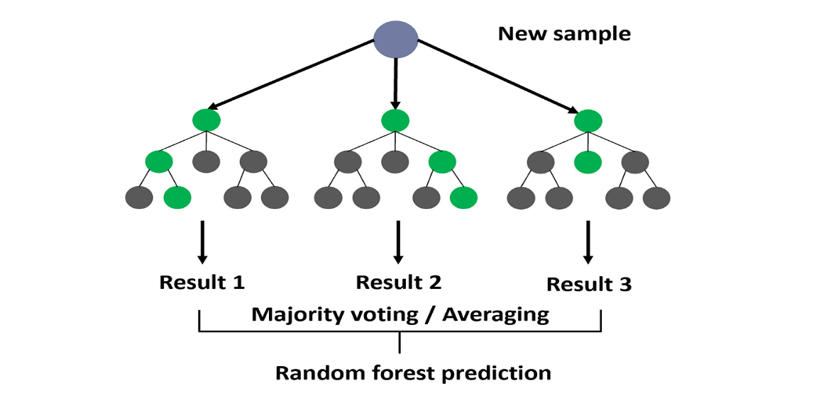

**2. Decision Tree Classifier:**

The decision tree constitutes a single of the stronger supervised learning algorithms, utilized in regression as well as classification. It creates a flowchart-like tree structure in which each internal node represents a test on a property, every branch represents the result of the evaluation, and each leaf node (terminal node) contains a class label. It is constructed by continually splitting the data used for training into subsets determined by the values of the characteristics until an endpoint is met, like the deepest level of the tree or the smallest number of examples required to broke a node.

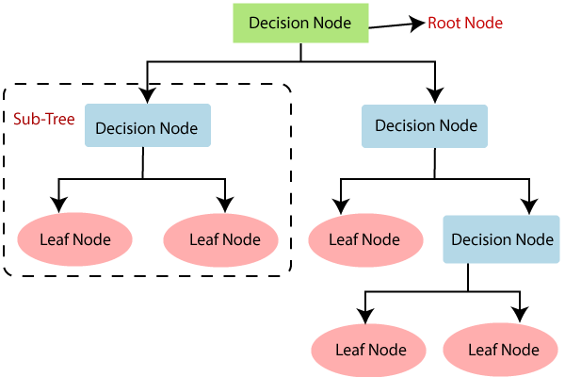

**3.** **The Multilayer Perceptron (MLP) Classifier:**

The Multilayer Perceptron classifier is a type of feedforward artificial neural network (ANN) commonly used for classification tasks, MLP classifiers are powerful models capable of learning complex patterns in data, creation them appropriate for a extensive variety of classification tasks.

Architecture:

1. **Layers**:

* **Input Layer**: This is the primary layer of the MLP, which receives the input features of the data. Apiece neuron in this layer signifies an effort feature.
* **Hidden Layers**: These are intermediate layers amid the input and output layers. An MLP container have one or more unseen layers, each consisting of multiple neurons. The unseen layers allow the network to learn composite symbols and patterns from the data.
* **Output Layer:** This is the final layer that foodstuffs the output of the model. In a classification task, the output layer typically has one neuron per class, and the output represents the probability of each class.

1. **Neurons**:

* Apiece neuron in a layer is linked to every nerve cell in the following layer. These influences are associated with weights that are attuned during exercise to minimalize the error in predictions.
* Neurons smear an start purpose to the weighted sum of their inputs, presenting non-linearity into the model and allowing it to learn complex functions.

In summary, the Multilayer Perceptron classifier is a foundational model in machine learning and neural networks, capable of learning and generalizing from data to make accurate predictions in a variety of complex tasks. Its flexibility and adaptability make it a crucial tool in the arsenal of data scientists and ML practitioners.

* **To build predictive models for child behavioral problems and identify the most influential factors:**

The goal of this research objective is to developed strong predictive model that can exactly forecast the likelihood of behavioral problems in children. Additionally, this objective aims to identify and analyze the key factors that most significantly influence these behavioral problems. Understanding these influential factors can provide valuable insights for parents, educators, and policymakers to implement effective interventions and support mechanisms for children at risk. By achieving these outcomes, the study will contribute to the broader field of child development and behavioral psychology, offering tools and knowledge to better support children's well-being and development.

Here we have built three predictive models for child behavioral problems and compared them with their overall accuracy and classification table. Thus, the models are as follows:

**Model Evaluation:**

To assess the presentation of the skilled organization models on the challenging set, we calculated the following metrics:

• Accuracy: The amount of correctly classified reviews

$=\frac{(TP+TN)}{(TP+TN+FP+FN)}$

• Precision: The amount of positive predictions that are actually correct

$=\frac{TP}{(TP+FP)}$

• Recall: The amount of real positive reviews the fittingly identified

= $\frac{TP}{(TP+FN)}$

• F1-score: The harmonic mean precision and recall

**1. Random Forest Classifier:**

Here's how we are performing the Random Forest classifier for a child behavioral problem on the dataset using Python:

**Output:**

|  |  |
| --- | --- |
| Overall Accuracy: | 0.87 |

**Classification Report:**

Table 5.8: Random forest classification table

|  |  |  |  |  |
| --- | --- | --- | --- | --- |
| Column1 | Precision | recall | f1-score | Support |
| No: 0 | 0.86 | 0.98 | 0.91 | 49 |
| Sometime: 1 | 0.94 | 0.7 | 0.8 | 23 |
| Yes: 2 | 0.8 | 0.67 | 0.73 | 6 |
|  |  |  |  |  |
| Accuracy |  |  | 0.87 | 78 |
| macro avg | 0.87 | 0.78 | 0.81 | 78 |
| weighted avg | 0.88 | 0.87 | 0.87 | 78 |

**Result and Conclusion:**

This means that the chance forest model correctly predicts the outcome 87% of the time. This is a good indicator that the model is performing well. These results suggest that the Random Forest model is effective in predicting child behavioral problems, though there may be room for improvement in identifying the "Sometime" and "Yes" cases.

**2. Decision Tree Classifier:**

Here's how we are performing the decision tree classifier for a child behavioral problem on the dataset using Python:

**Output:**

|  |  |
| --- | --- |
| Overall Accuracy: | 0.85 |

**Classification Report:**

Table 5.9: Decision tree classification table

|  |  |  |  |  |
| --- | --- | --- | --- | --- |
| Column1 | Precision | recall | f1-score | Support |
| No: 0 | 0.84 | 0.96 | 0.90 | 49 |
| Sometime: 1 | 0.93 | 0.61 | 0.74 | 23 |
| Yes: 2 | 0.71 | 0.83 | 0.77 | 6 |
|  |  |  |  |  |
| Accuracy |  |  | 0.85 | 78 |
| macro avg | 0.83 | 0.80 | 0.80 | 78 |
| weighted avg | 0.86 | 0.85 | 0.84 | 78 |

**Result and Conclusion:**

The Decision Tree classifier demonstrates robust performance in predicting child behavioral problems, with an overall accuracy of 85%. The precision and recall metrics indicate that the model is particularly effective in identifying instances where there are no behavioral problems (class "No"). However, the model is less effective in identifying "Sometime" and "Yes" cases, as evidenced by their lower recall values.

**3. The Multilayer Perceptron (MLP) Classifier:**

Here's how we are performing the Multilayer perceptron (MLP) classifier for a child behavioral problem on the dataset using Python:

**Output:**

|  |  |
| --- | --- |
| Overall Accuracy: | 0.88 |

**Classification Report:**

Table 5.10: Multilayer Perceptron (MLP) classification table

|  |  |  |  |  |
| --- | --- | --- | --- | --- |
| Column1 | Precision | recall | f1-score | Support |
| No: 0 | 0.90 | 0.94 | 0.92 | 49 |
| Sometime: 1 | 0.82 | 0.78 | 0.80 | 23 |
| Yes: 2 | 1.00 | 0.83 | 0.91 | 6 |
|  |  |  |  |  |
| Accuracy |  |  | 0.88 | 78 |
| macro avg | 0.91 | 0.85 | 0.88 | 78 |
| weighted avg | 0.88 | 0.88 | 0.88 | 78 |

**Result and Conclusion:**

The Multilayer Perceptron (MLP) classifier demonstrates strong performance in predicting child behavioral problems, with an overall accuracy of 88%. The precision and recall metrics indicate that the model is particularly effective in identifying instances where there are no behavioral problems (class "No").The results indicate that the MLP classifier can be a reliable tool for predicting child behavioral problems.

* **Comparing the accuracy of the models and identify the most influential factors:**

In the study of predicting child behavioral problems, we applied and evaluated three ML classifiers: Random Forest, Decision Tree, and Multilayer Perceptron (MLP). Here we are comparing the overall accuracy of these three machine learning models. Based on this comparison, we can identify the best model and most influential factor that can affect child behavioral problems.

Table 5.11: Comparison of the model'saccuracy

|  |  |
| --- | --- |
| Model | Accuracy |
| Random Forest classifier | 0.87 |
| Decision Tree classifier | 0.85 |
| Multilayer Perceptron (MLP) classifier | 0.88 |

From Table 5.11 Comparing the performance of the three classifiers, the Multilayer Perceptron (MLP) showed the highest overall accuracy (0.88) and balanced performance across all classes. The Random Forest model also performed well, particularly in identifying the "No" class instances, and provided insights into the most influential factors affecting child behavioral problems.

* **Identifying the Most Influential Factors:**

To determine the most influential factors affecting child behavioral problems, we analyzed the feature importance derived from the MLP model and examined the coefficients of the model.

Importance of Identifying Influential Factors:

1. **Targeted Interventions:** By knowing which factors have the most significant impact on child behavioral outcomes, interventions can be more effectively designed to address specific issues.
2. **Resource Allocation:** Resources can be allocated more efficiently to areas that will have the greatest impact on improving child behavior.
3. **Policy Making:** Informing policy makers about critical factors helps in creating supportive policies for children and families.

Here's how we are performing the Multilayer perceptron (MLP) classifier for a feature importance on the dataset using Python:

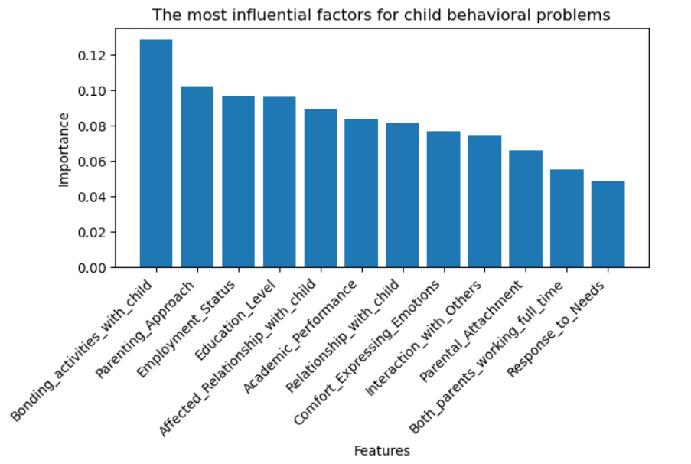

Fig: 4.5

**Conclusion:**

The study identifies key factors affecting children's behavioral development, such as bonding activities, parenting approach, employment status, education level, and the excellence of the parent-child association highlight the importance of a supportive and progressive environment for children's behavioral development. These factors can inform interventions and strategies to improve child behavior by enhancing parental engagement and relationship quality. Understanding and addressing these factors can lead to targeted and effective interventions, improving child behavior and overall family dynamics.

**Chapter-VI**

**RESULT AND DISCUSSION**

1. The graph shows that children aged 45-60 feel most comfortable expressing their emotions to their parents, likely due to older parents' maturity, patience, understanding, and emotional support.
2. The graph reveals that children with a freely parenting attachment style exhibit more positive interactions, indicating improved social behaviors. This supportive environment encourages children to explore social interactions, leading to enhanced social skills.
3. The study identified key factors influencing children's academic performance using multinomial logistic regression models. The models predicted the probability of a child falling into each category. The accuracy was 70.3%, with each category ranging from 59.5% to 73.4%. The findings offer valuable insights for parents, educators, and representatives in developing strategies for supporting academic success.
4. Through our analysis, we observed a significant interaction effect amid parent addon and parenting approach on the quality of the parent-child connection.the study suggests that increased parent attachment and childrearing style significantly impact the quality of the parent-child relationship, as these factors directly influence the strength and satisfaction levels of the relationship between parents and children.
5. Our analysis indicated that there is a important association amid child gender and parenting styles. This suggests that parents treat their children differently based on their gender. The study reveals that gender significantly influences parenting approaches, leading to varying expectations and behaviors. This suggests a need for gender-sensitive parenting to promote equal opportunities and development for all children.
6. The study highlights the importance of a supportive environment for children's behavioral development, highlighting factors like bonding activities, parenting approach, employment status, education level, and parent-child relationship quality for effective interventions has the highest impact on predicting behavioral glitches.